**Teaching Note**

**Cannonball!**

***Sondra Simpson, Elmhurst College***

*This teaching note was prepared by the authors and is intended to be used as a basis for class discussion. The views presented here are those of the authors based on their professional judgment and do not necessarily reflect the views of the Society for Case Research. The names of individuals, the firm, and its location have been disguised to preserve anonymity. Copyright © 2015 by the Society for Case Research and the authors. No part of this work may be reproduced or used in any form or by any means without the written permission of the Society for Case Research.*

**Critical Incident Overview**

Laura was working as an area supervisor for a large swimming pool management company that dealt primarily with private community pools. She had three prior years of experience working for the company as a pool lifeguard and had just been promoted to supervisor at the beginning of the summer. Her territory included nine pools and roughly seventy lifeguards. They were midway through the summer season and things were going well despite the fact that the company was understaffed for lifeguards. One night Laura received a call from the president of a homeowners’ association regarding its pool. Two guards, Jessica and Emily worked at the private community pool. One night they used their company keys to access the pool after hours to allow themselves and a group of ten friends to swim. The president of the community’s homeowners’ association discovered the group sometime after 10 p.m. The police were not involved despite the trespassing violation due to the fact that one of the girls lived in the community. Company policy states that employees are allowed in the pool facilities only during the times of their scheduled shifts. Their performance prior to this had been adequate but not outstanding. The pool was constantly understaffed despite the heavy use of the facilities.

This decision critical incident case relates to problem solving using managerial concepts, the importance of effective communication and managing professional relationships.

This case is most appropriate for undergraduate courses in Organization Behavior, Human Resource Management and Principles of Management Theory.

**Research Methods**

The decision critical incident described was written by the authors based upon an event described in an in-depth interview with a former employee of the company who witnessed the situation. To protect the interviewee and preserve anonymity, the names of the company and those involved, along with the location have been disguised. This decision critical incident case has been classroom tested in an undergraduate Organization Behavior course.

**Learning Outcomes**

In completing this assignment, students should be able to:

1. Evaluate the situation using knowledge of managerial concepts to help effectively manage the situation
2. Recognize the implications of the management’s response to the current situation in relation to possible future incidents
3. Determine the importance of effective communication in expressing and upholding company expectations and policies
4. Demonstrate an understanding and ability to communicate with different levels of personnel within a company

**Discussion Questions**

1. What arguments can be made for terminating employment of the guards on the spot? (LO 1)
2. As the guards’ supervisor, what course of action would you have taken in the given situation? Why? (LO2)
3. How would you follow up with the homeowners’ association to repair the trust and relationship between the two organizations? (LO3)
4. What could be some possible adverse effects for the company of releasing the guards before the end of the season? (LO4)
5. If you were this supervisor’s manager, how would you recommend they handle the situation? (LO4)

**Answers to Discussion Questions**

1. **What arguments can be made for terminating employment of the guards on the spot? (LO 1)**

Some students will argue that the staff should be fired. Others will suggest this is not the case. These options are explored more fully in the subsequent questions. However, this question first addresses the concept of termination in this context and is best discussed after reading a chapter on ethics and integrity.

The argument can be made that the guards were in flagrant violation of the company’s policy regarding employees’ use of pool facilities outside of their scheduled shifts. In this situation, Laura had to act with integrity. This means to adhere to an ethical code or standard, such as the standards set by the pool company.

Additionally, the pool was closed and therefore the guards were trespassing on private property. Finally, it posed a liability issue to the company because industry standards require that a certified lifeguard be on duty whenever people are present in the pool area. Applying the concept of universalism, which states that the situation should be evaluated based upon whether or not other individuals in the same situation would make the same decision, further supports this argument. It can easily be stated that other managers in similar situations would be quick to make the decision to release the guards based upon the previously stated reasons.

Finally, this scenario poses a question of conflicting ethical commitment, which is the principle stating a dedication or desire to do what is right even in the face of potentially harmful personal repercussions. Firing the guards on the spot would align with a strong ethical commitment because it demonstrates the employee holding the company’s values and policies above all else.

1. **As the guards’ supervisor, what course of action would you have taken in the given situation? Why? (LO 2)**

Many common problem solving models can be used to address this question. These can either be researched in a search by the students, developed in class collaboratively with the instructor and then used to answer the question or covered in chapter readings from typical organizational behavior or management text books. The author used the following model in classroom testing:

*PADIL* (pronounced paddle). This is an acronym to describe the five key steps in the problem-solving process: problem, alternatives, decide, implement, and learn. It is an amalgamation of several problem solving models and covers the basic steps described in most variations (Baldwin, Bommer and Rubin 2013, 91-103).

*Problem* ***-***The guards’ actions were in flagrant violation of company policy and misuse of company resources.

*Alternatives –* The supervisor had many alternatives to choose from. These alternatives included firing the guards on the spot, implementing a disciplinary probation period on the guards, verbal warning or waiting for direction from upper-management. (Note: some students in our class brought in the concept of *Ethical Consciousness.* The author of this critical incident defines this as essential in weighing all of the possible consequences of each individual alternative. Ethical consciousness is the ability to understand the ramifications of choosing less ethical courses of action.).

*Decide* ***–*** After weighing all of the possible outcomes of each alternative course of action, Laura decided upon firing the guards on the spot. This course of action should be chosen because it most closely aligns with company standards and policies and would act to prevent similar circumstances from occurring in the future. (Note: At this point the instructor can also discuss how *moral intensity*plays a role in reaching a decision in responding to the situation. Moral intensity is defined as the degree to which an issue demands the application of ethical principles. The author of this case has deemed the actions in response to the situation to be of low to moderate moral intensity due to the small amount of people effected by the decision.). Like Ethical Consciousness, moral intensity is a common term provided in most contemporary management, organizational behavior and human resource text books.

*Implement* ***-*** Implement by verbally expressing to the guards that they have been released of their positions and follow-up by performing necessary documentation.

*Learn* ***-*** Learn from the situation by evaluating how company policies are conveyed in training and upheld in daily practices in order to prevent a similar circumstance from occurring in the future.

1. **How would you follow up with the homeowners’ association to repair the trust and relationship between the two organizations? (LO 3)**

*Relationship Conflict,* which is conflict that arises from incompatible or strained personal interactions, is the main issue regarding this aspect of the scenario. In this case we used the Thomas-Kilmann Conflict Resolution Grid which includes five conflict management responses mapped on a scale of achievement of own interest vs response to other’s interest. These responses are compete, collaborate, compromise, avoid and accommodate. The following is an adapted grid created by the author:

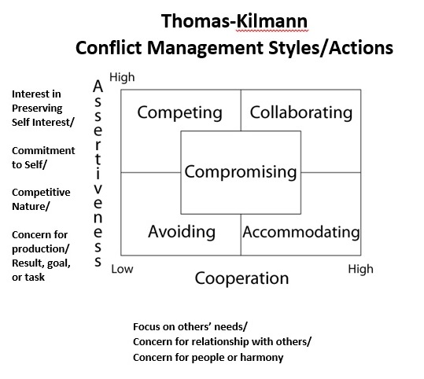

This conflict resolution grid can be found in most textbooks and has become so common it is often not even attributed to Thomas and Kilmann but simply labeled “A Conflict Grid” or “Conflict Management Styles”.

It can be a worthwhile activity to break students into five small groups and ask each group to determine how they would respond given a specific style of conflict resolution action. In this incident, the “accommodate” and “collaborate” actions were explored during the in-class test. It is felt, by the authors that collaboration is the best conflict management style or action when it can be utilized.

In the immediate situation, Laura could employ *accommodation* by firing the guards on the spot. Accommodation is behaving in a supportive, submissive, unassertive, and cooperative manner. By firing the guards, she would accommodate the wishes of the homeowners’ association in using strong immediate disciplinary action. This could be the first, necessary step in repairing the relationship with the homeowners’ association.

To repair the trust and relationship between the two organizations, it is recommended to keep the president informed of the situation as it unfolds. By keeping all parties involved and updated about developments regarding the situation as they occur, this could be a collaborative action. Specifically, Laura could *collaborate* with the homeowners’ association to come up with a plan to ensure a similar situation does not occur in the future and develop a clear disciplinary scheme to handle similar situations should they ever arise. Together, they could clearly communicate this plan with the homeowners’ association and ensure they communicate approval of the adopted plan.

1. **What could be some possible adverse effects for the company of releasing the guards before the end of the season? (LO 4)**

In order to properly determine this, the manager needs to employ the *transactional theory* **model** to determine what sort of stress the negative effects of this decision would have on the pool’s working environment. Transactional theory is a theory which suggests that stress a person feels can cause negative effects. These are as a result or function on the interaction (or transaction) between the person and their environment in a given situation (Lazarus and Folkman, 1987).

The primary adverse effect of the decision to release the guards early is that the pool would be even more understaffed than it already was. Some may accuse the manager of *satisficing* (defined as settling for the first alternative that meets some minimum level of acceptability). They could argue that she did not think out the strain this decision causes on both the supervisor and the lifeguards at that pool. The supervisor is put under pressure to find replacements for the guards quickly. The lifeguards currently employed by the company are forced to work more shifts in order to compensate, which can lead to increased stress, decreased morale and overall dissatisfaction with the company and its working environment. Ultimately, it could potentially create a stressful environment that adversely affects the employees as a whole. This could affect the customers, or those using the pool, as well.

1. **If you were this supervisor’s manager, how would you recommend they handle the situation? (LO 4)**

Student responses here can vary widely. The important thing is that they support their recommendations.In addition to terminating the employees the supervisor has several other options to rectify the situation. There are a number of variations of performance management systems published and readily available to use to analyze this question. The instructor can ask students to read the appropriate chapter in their textbook or conduct a search and build a model. For the organizational behavior class this CI was tested in, the author chose to have students consider the *performance management cycle (PMC)* which is to establish expectations, assess performance, and provide feedback and development (Baldwin, Bommer and Rubin 2013, 244-251). See the exhibit below to discuss the steps Laura could take. Using this framework, students in the test class determined that Laura could recommend holding off on immediate termination and instead suggest having a meeting with the individuals to discuss their actions and come up with a suitable disciplinary action plan. After this you could follow up with the entire staff to ensure that they all understand company policy and the consequences of not adhering to these policies. Ultimately, moving forward, you should strive to create a working culture that upholds these company policies and standards.

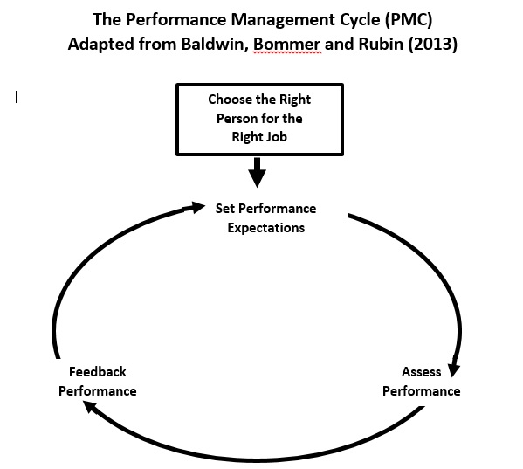

**Other Pedagogical Materials**

This case was classroom tested by an undergraduate Organization Behavior class. The class discussion of the case focused on concepts including integrity, moral intensity and ethical commitment. There was also discussion surrounding performance management and decision-making.

1. Students could gain additional benefits from discussing the scenario in small groups and applying concepts learned in class and from readings to the scenario.
2. Divide the classroom into four equal sized groups. Ask each one of the first four questions provided in this teaching note. Emphasize the importance of applying concepts learned in class and from the book to the scenario.
3. Allow about ten minutes for the groups to thoroughly discuss their assigned questions and find concepts to apply. Aid in discussion as needed. At the end of the allotted time, regroup as a class and have a spokesperson from each group report their discussion and findings to the class. We used marker boards to aid in discussion.
4. Pose the final question (question 5) as an open discussion question for the entire class to discuss. Supplement the discussion by asking supporting questions or playing devil’s advocate in response to their assertions. One faculty suggestion is to have students post their responses, critique them using a 4S method developed by Larry Michaelsen and the Team Based Learning group.
5. An additional activity would be to have the students read the following two articles in addition to their text book prior to analyzing the case and use these as frameworks for discussion:
   * Brown, Jennifer Gerarda (2012). Empowering Students to Create and Claim Value through the Thomas-Kilmann Conflict Mode Instrument EmpoweringStudents through the TKI. *Negotiation Journal* (0748-4526), 28 (1), p. 79.
   * Taylor, D. (2009). Tools of The Trade At Work. *Training Journal*, 61-62.
   * Valencia, P. (2015). Trouble IS Brewing. *TD: Talent Development*, *69*(4), 60-64.
6. Provide the class the Conflict Management Grid provided in the answers to the questions.
7. Break into small groups exploring the pros and cons of each approach in this case.-or-
8. As a large group determine recommended actions for each approach and then develop a recommendation.



1. Ahead of time, provide the class the PMC model and ask them to brainstorm ways this can be managed given Laura’s situation (see below). Compare this process to one of the latest thought leader thought leader articles on the subject:
   * Buckingham, M., & Goodall, A. (2015). Reinventing Performance Management. (cover story). *Harvard Business Review*, *93*(4), 40-50.



**Epilogue**

Laura’s manager followed up with her regarding the situation the next day. He stated that she had acted in accordance with company policy and procedure and commended her for handling the situation respectfully and swiftly. She was able to finish out the season as supervisor without any other major incidents.

The firing of the guards did lead to the pool being temporarily understaffed. Laura was required to temporarily take on lifeguarding responsibilities to compensate for the loss of personnel. After aggressively recruiting new guards for two weeks, Laura was able to find two suitable and qualified candidates to fulfill the vacant positions.

Laura’s manager handled repairing the relationship with homeowner’s association. PPS wanted to show the association how seriously they took the situation and tried to prove this by involving upper-management. Laura had to interact with the president several times following the incident and he showed no signs of harboring anger or resentment towards the company or her personally.

**References**

Baldwin, T., Bommer, W.H., and Rubin, R. S. (2013). *Managing organizational behavior: What great managers know & do*. New York: McGraw-Hill Irwin.

Brown, J.G. (2012). Empowering students to create and claim value through the

Thomas-Kilmann Conflict Mode Instrument *Negotiation journal* (0748-4526), 28 (1), p. 79.

Buckingham, M., & Goodall, A. (2015). Reinventing performance management.

*Harvard business review*, *93*(4), 40-50.

Lazarus, R., and Folkman, S., (1987). Transactional theory and research on emotions and

coping. *European journal of personality*, 1 (3, Spec. Issue), 141-169.

Taylor, D. (2009). Tools of the trade at work. *Training journal*, 61-62.

Valencia, P. (2015). Trouble IS brewing. *TD: Talent development*, *69*(4), 60-64.